EX1: Write a C program, which prints to console “Hello World!”. Compile it! Run objdump -h executable_name and identify the zones described above. Find the stack zone and the heap zone. Identify the addresses from where each zone starts.

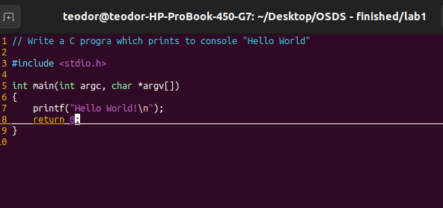
Now we compile the program:

Run objdump -h executable_name → Display the contents of the section headers using -h option (There can be various sections in an object file. Information related to them can be printed using -h option).
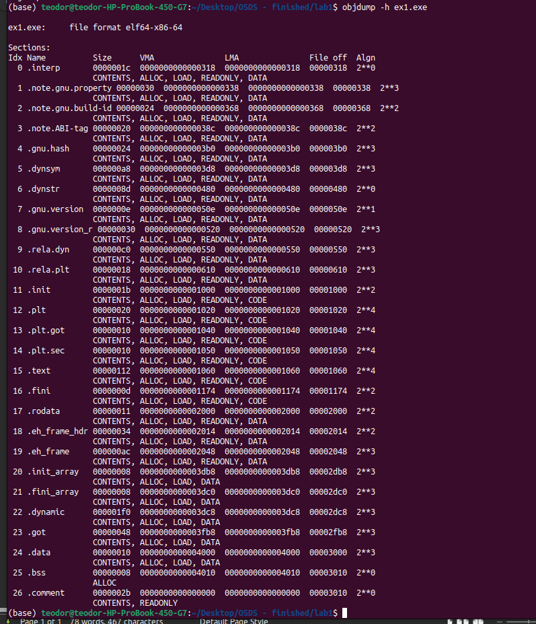
The zones described above:
Size → the dimension of the section
VMA → Virtual Memory Address
LMA →Logical Memory Address
File off → the offset of the section from the start of the file
Algn → the alignment

CONTENTS, ALLOC, LOAD, READONLY, DATA → flags

Find the stack and the heap zone:
The stack (.eh_frame) and the heap (.dynamic) zones cannot be identified (they are created dynamically during compiling time) because our program does not have stack frames (who appear whenever we have function calls) or dynamic allocations (the heap zone is dedicated for this problem)

Identify the addresses from where each zone starts:

Identified zones:
- Text/Code Zone: 0000000000001060
- .data: 0000000000004000
- .rodata: 0000000000002000
- .bss: 0000000000004010

EX2: Create a loop in your program, to prevent it from ending. Run the command cat proc/pid_number/maps – where pid_number is the pid of your process. Find where the stack and heap are mapped. See that there are other things mapped in your process; please identify what they are. Run now the command ldd executable_name – what do you observe and what is the relation with the mapping your previously observed?

Loop in the program:
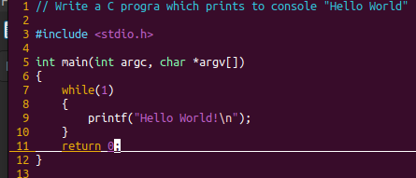

For finding the PID we run: pidof executable_name

While running the ex2.exe, we open a new terminal, we find the PID and we run the command cat/proc/pid_number/maps where pid_number is the pid found above

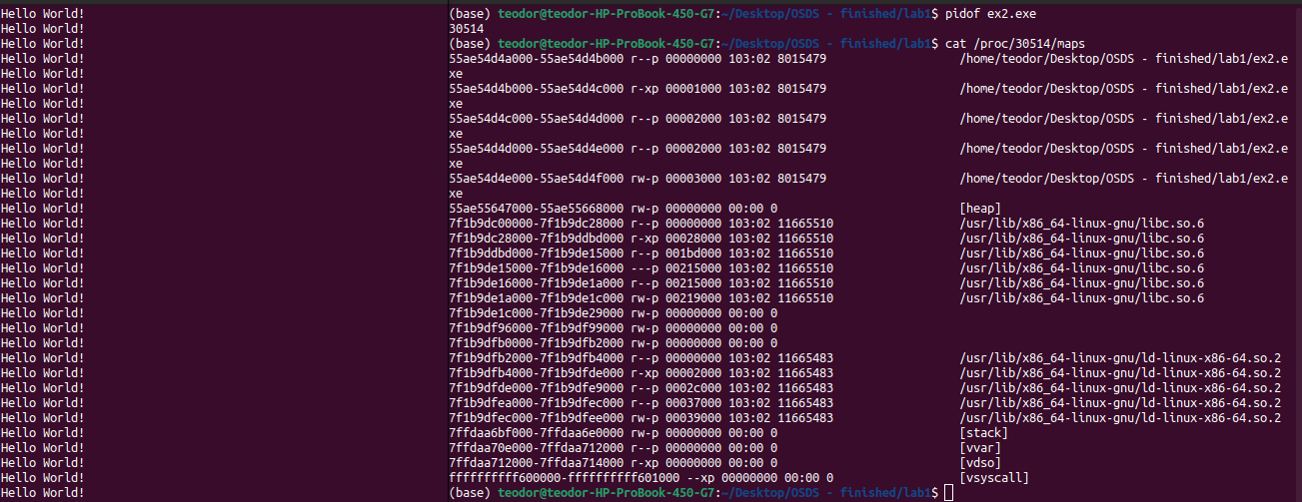
The meaning of each column:
- address : the address of the start and of the end of the process regions
- perms (permissions) : the access permissions (r – read, w-write, x-execute, s-shared, p-private)
- offset: if the region was mapped from a file using mnap → the offset of the file where the map began
:if the memory was not mapped from a file : it’s 0
- dev (device): if the region was mapped from a file, this is the number of device major and minor (hex) where the file can be found
- inode: if the region was mapped from a file → it’s the name of the file
- pathname: If the region was mapped from a file, it’s the name of the file (libc and ld are libraries). This field is empty for anonymous mapped regions.

The following command ldd executable_name → allows users to view an executable file’s shared object dependencies

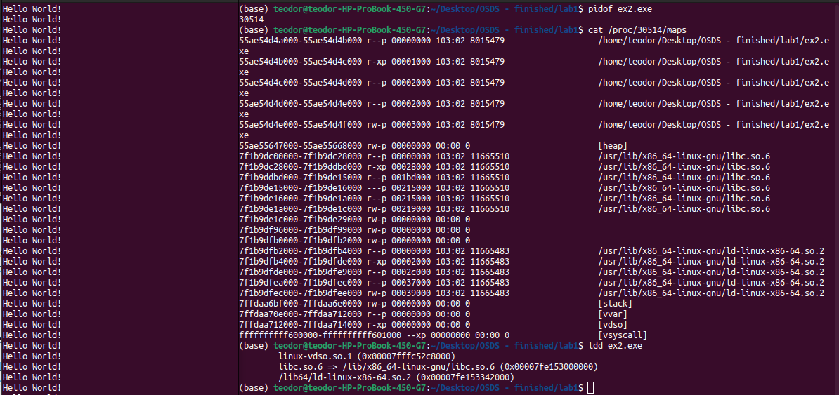
The command also shows the libraries from which our program depends of and the virtual memory of these libraries. Obs: each library has in memory more than one zone of memory, so the address is different from the previous executed command.

EX3: Write a C program which allocates a zone of virtual memory with only read only rights. Register a handler for SIGSEGV signal. Create a pointer to an address in the read only zone you just created and try to write at that address. Find in the handler registered to handle SIGSEGV signal that the address where the access violation was produced and change the rights on the page with mprotect function

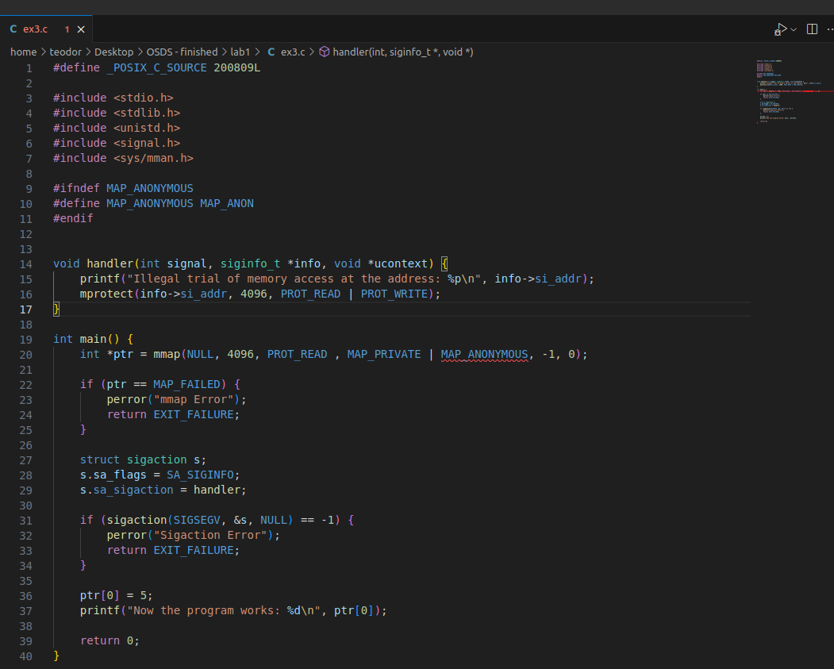
EX4: Discussion:
- If I send a signal process which has more than one thread which thread will handle it?
A process-directed signal may be delivered to any one of the threads that does not currently have the signal blocked. If more than one of the threads has the signal unblocked, then the kernel chooses an arbitrary thread to which to deliver the signal. There is also the possibility of implementing a handling system in order to let the programmer chooses a specific thread
- If a thread produces an invalid memory access, which thread will handle it?
The thread itself using SIGSEGV

